**KS3 Transitioning: Science**

The Science department would like you to amaze us with your Science knowledge over the summer. Try to answer some of the questions that we have put together for you below, and have a look at some of the books we have recommended.

**Living and Non-Living Things**

The way we can decide of something is alive or not alive is to look at the 7 characteristics of living things

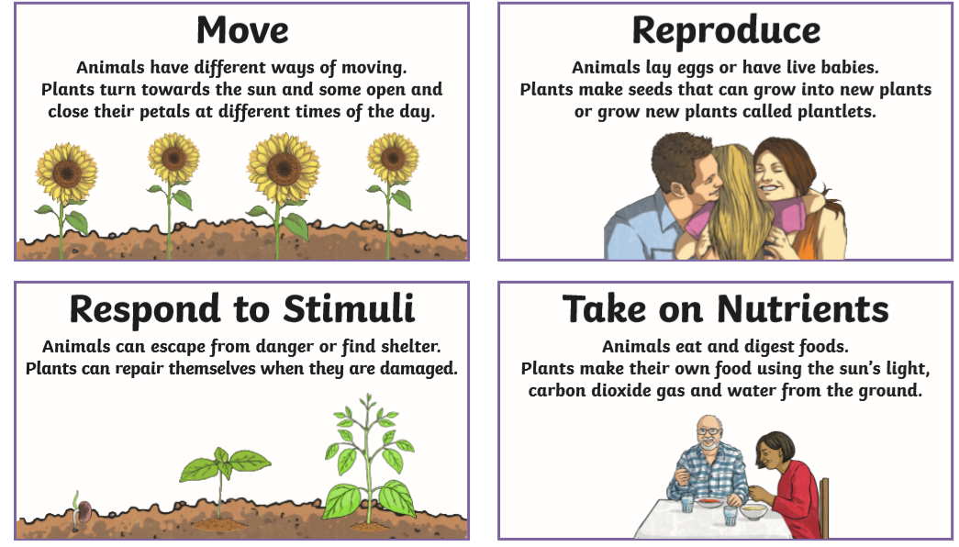

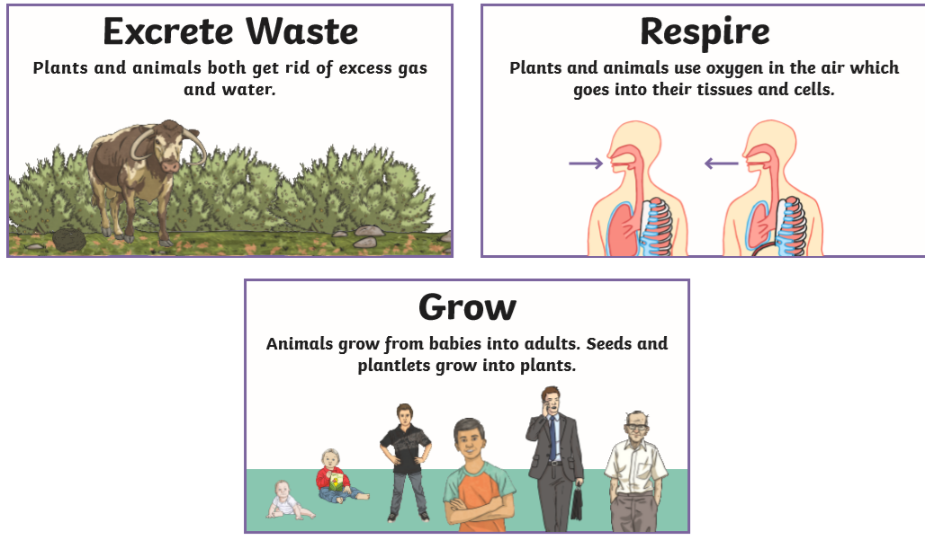

**List the 7 characteristics of living things**:

1.\_\_\_\_\_\_\_\_\_\_\_\_\_\_\_\_\_\_\_\_\_\_\_\_\_

2.\_\_\_\_\_\_\_\_\_\_\_\_\_\_\_\_\_\_\_\_\_\_\_\_\_

3.\_\_\_\_\_\_\_\_\_\_\_\_\_\_\_\_\_\_\_\_\_\_\_\_\_

4.\_\_\_\_\_\_\_\_\_\_\_\_\_\_\_\_\_\_\_\_\_\_\_\_\_

5.\_\_\_\_\_\_\_\_\_\_\_\_\_\_\_\_\_\_\_\_\_\_\_\_\_

6.\_\_\_\_\_\_\_\_\_\_\_\_\_\_\_\_\_\_\_\_\_\_\_\_\_

7.\_\_\_\_\_\_\_\_\_\_\_\_\_\_\_\_\_\_\_\_\_\_\_\_\_

**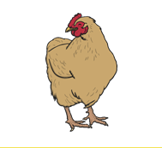Use the 7 characteristics of living things to decide if the following are living or non-living.**

Can a chicken move?\_\_\_\_\_\_\_\_\_

Can a chicken reproduce (does it lay eggs and have baby chickens)?\_\_\_\_\_\_\_\_\_

Can a chicken respond to stimuli (if it sees a fox will it run away and hide)?\_\_\_\_\_\_\_\_\_

Can a chicken take on nutrients (does it eat food)? \_\_\_\_\_\_\_

Does a chicken excrete waste (does it poop)?\_\_\_\_\_

Does a chicken respire (does it need oxygen)?\_\_\_\_\_\_

Does a chicken grow?\_\_\_\_\_\_\_\_

Is a chicken living or non-living?\_\_\_\_\_\_\_\_\_\_\_\_\_\_\_\_\_

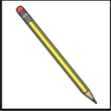

Can a pencil move by itself?\_\_\_\_\_\_\_\_\_

Can a pencil reproduce (can it have baby pencils)?\_\_\_\_\_\_\_\_\_

Can a pencil respond to stimuli (can it run away if it’s in danger or can it repair itself)?\_\_\_\_\_\_\_\_\_

Does a pencil take on nutrients (does it eat food)? \_\_\_\_\_\_\_\_

Does a pencil excrete waste (does it poop)?\_\_\_\_\_

Does a pencil respire (does it need oxygen)?\_\_\_\_\_\_

Is a pencil living or non-living?\_\_\_\_\_\_\_\_\_\_\_\_\_\_\_\_\_

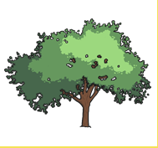

Is a tree living or non-living?\_\_\_\_\_\_\_\_\_\_\_\_\_\_\_\_\_

Hint: It needs oxygen and it makes its own food.

When the leaves fall off that’s how it gets rid of its waste

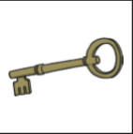

Is a key living or non-living?\_\_\_\_\_\_\_\_\_\_\_\_\_\_\_

Why do you think this? \_\_\_\_\_\_\_\_\_\_\_\_\_\_\_

|  |  |  |  |
| --- | --- | --- | --- |
| test tubes1 | -test_tube_holder2 | balance3 | bunsen 24 |
| bunsen trisatnd5 | burettes6 | clamp stand7 | -clear-conical-flask8 |
| evaporating dish9 | gauze_mat10 | funnel11 | test tube rack12 |
| glass beaker13 | 14  goggles | 15  lab-thermometer | 16  magnifying glass |
| measuring cylinders17 | microscope18 | pestle and mortar19 | petri dish20 |
| 21  pipette | stop watch22 | round bottomed flask23 | spatula24 |

**Match the equipment to its correct name**

spatula petri dish test tube rack burette

round bottomed flask pestle and mortar funnel tripod

stop watch microscope gauze bunsen burner

pipette measuring cylinder evaporating dish balance

magnifying glass thermometer conical flask tongs

goggles glass beaker clamp stands test tubes

Can you think of examples of how each piece of equipment could be used?

See if you can find some pictures of the equipment being used in Scientific experiments.

Chromatography

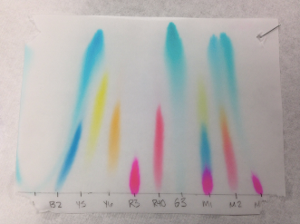Chromatography is a method used to separate mixtures. It separates substances in a mixture. It works when the substances in a mixture are soluble in the same solvent (liquid). The picture made by chromatography is called a chromatogram.

Complete the sentences below.

• Chromatography separates substances in ……………………

• It works if all the substances in the mixture are soluble in……………………..

• The picture made by chromatography is called a ……………………………..

Acids & Alkalis

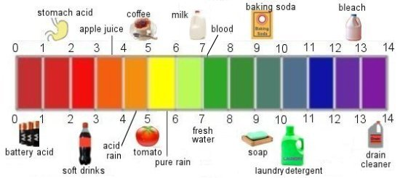

Which of these substances are acids?

Which of these substances are alkalis?

How do you know?

**Finally here are some recommended books to read over the summer:**

**The Bacteria Book: The Big World of Really Tiny Microbes by Steve Mould**

<https://books.google.co.uk/books?id=NsJSDwAAQBAJ&printsec=frontcover&dq=Finally+here+are+some+recommended+books+to+read+over+the+summer:++The+Bacteria+Book:+The+Big+World+of+Really+Tiny+Microbes+by+Steve+Mould&hl=en&sa=X&ved=2ahUKEwiV4Onbx5fqAhW0unEKHerzDHwQ6AEwCXoECAUQAg#v=onepage&q&f=false>

**The Element in the Room: Investigating the Atomic Ingredients That Make Up Your Home by Mike Barfield**

<https://books.google.co.uk/books?id=TifFtAEACAAJ&dq=the+element+in+the+room&hl=en&sa=X&ved=2ahUKEwjJm4PIyJfqAhVbRBUIHUMvBooQ6AEwAHoECAEQAg>

**Planetarium: Welcome to the Museum by Raman Prinja and Chris Wormell**

<https://books.google.co.uk/books?id=fXtqDwAAQBAJ&printsec=frontcover&dq=Planetarium:+Welcome+to+the+Museum&hl=en&sa=X&ved=2ahUKEwj6zvCmyZfqAhWVonEKHbLJAVQQ6AEwAHoECAUQAg#v=onepage&q=Planetarium%3A%20Welcome%20to%20the%20Museum&f=false>